3.

(a) How many players have an unknown birthdate?



Without any index:



Only primary key:





Add index:





Thus, we can see the approximated number of rows to scan when adding index is much lower than that of only primary and without any indexes.

(b) How many people are in the Hall of Fame? What fraction of each category of person are in the Hall Of Fame? Are more people in the Hall Of Fame alive or dead? Does this vary by

category?

How many people are in the Hall of Fame?



Without any index:



With primary key only:





With Foreign key and primary key:



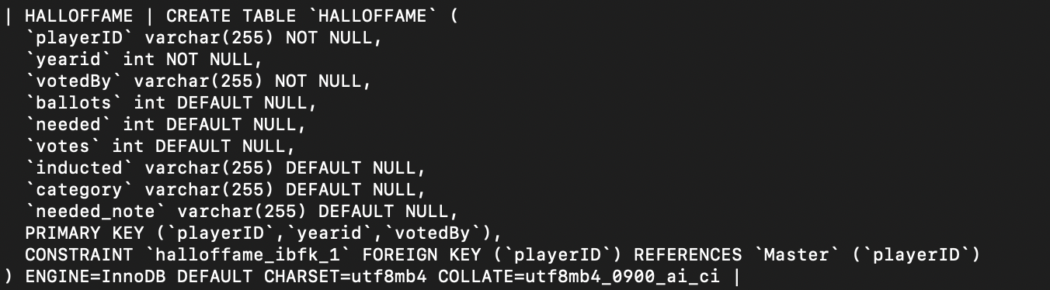



Add indexes:





What fraction of each category of person are in the Hall Of Fame? Are more people in the Hall Of Fame alive or dead? Does this vary by category?

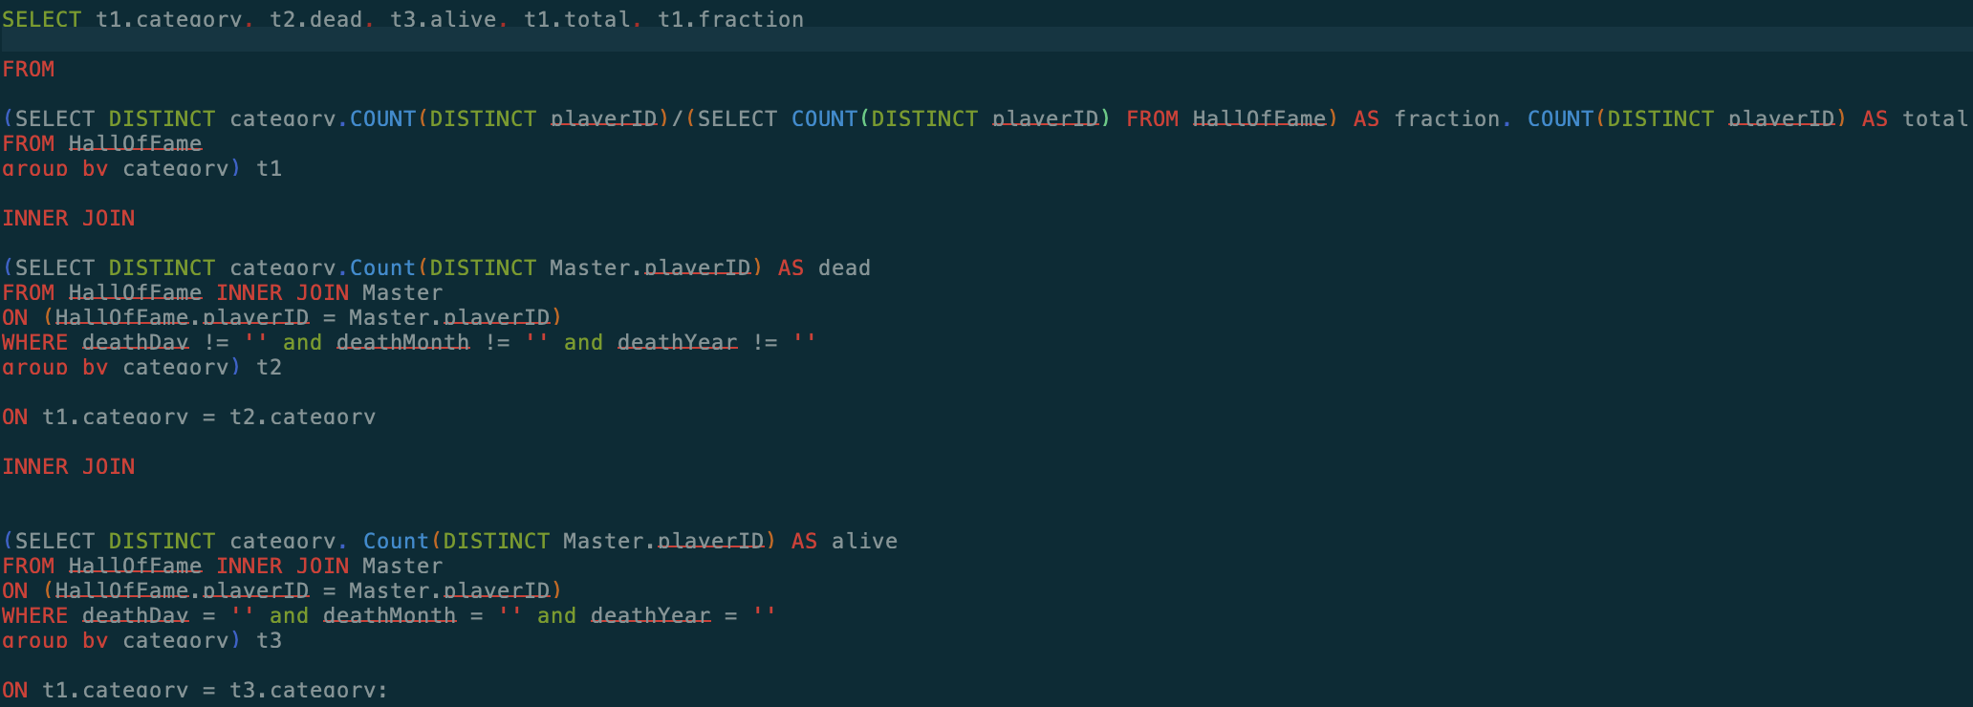

Without any index:

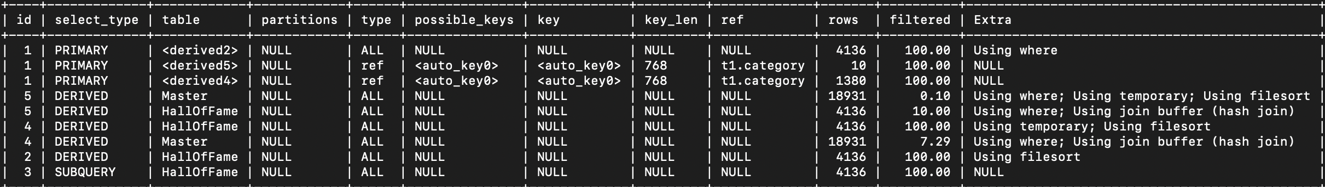

Only with primary key:





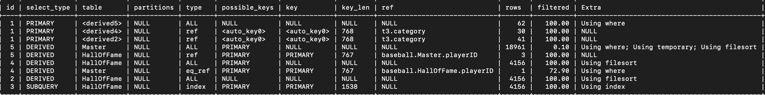

With primary key and foreign key:





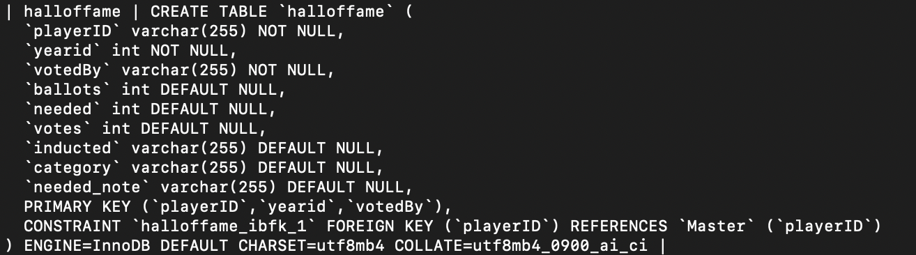

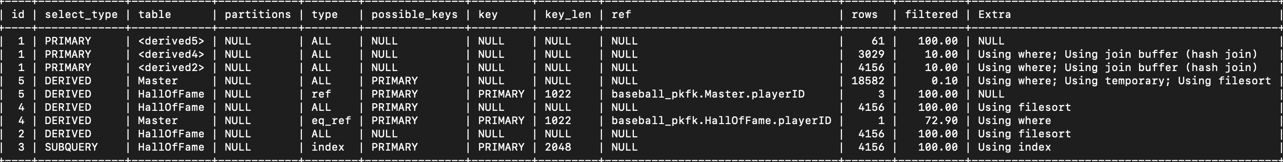

Add index on category:

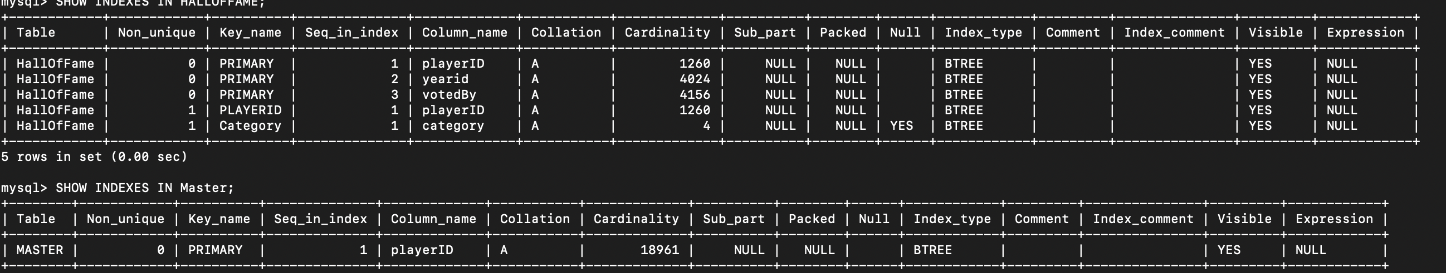

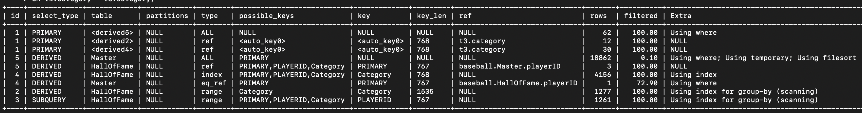

(c) What are the names and total pay (individually) of the three people with the three largest total salaries? What category are these people (Players? Managers? Other?)? What are the top three by category?

What are the names and total pay (individually) of the three people with the three largest total salaries?

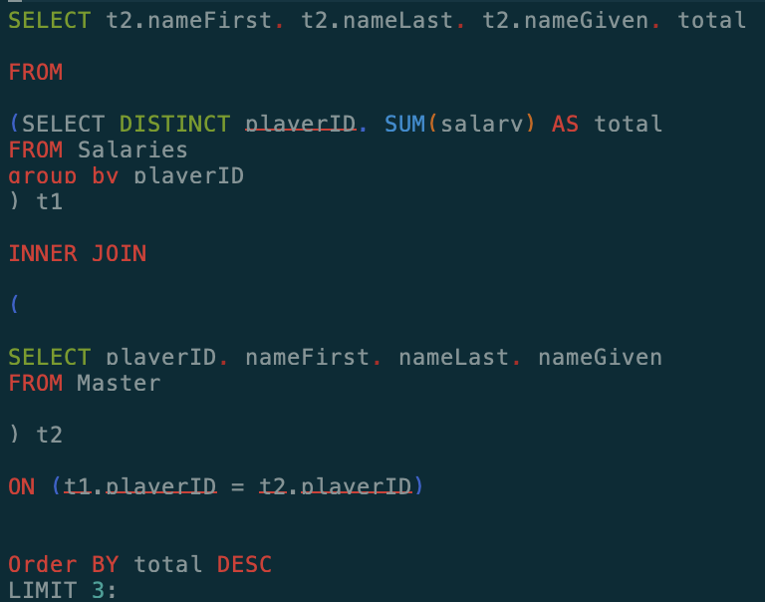

Without any index:



Only with primary key:







With pk and fk:







With index:

All the needed index has been in with pk and fk.

What category are these people (Players? Managers? Other?)? What are the top three by category?

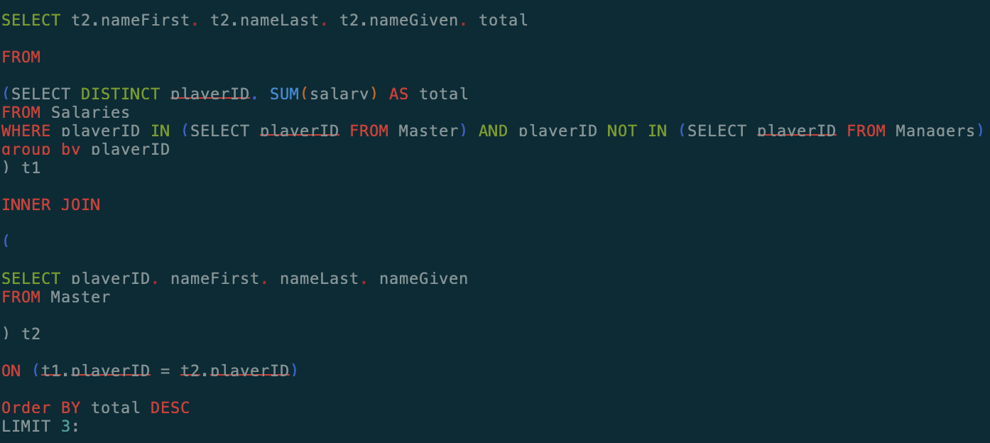

Players Only:

Without any index:

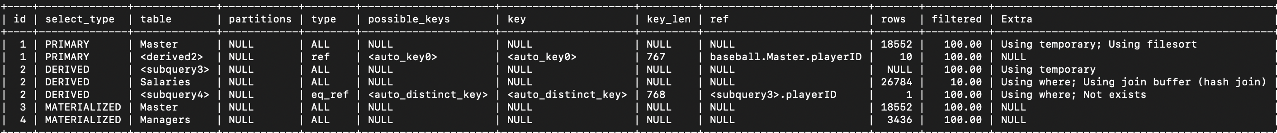

With pk:

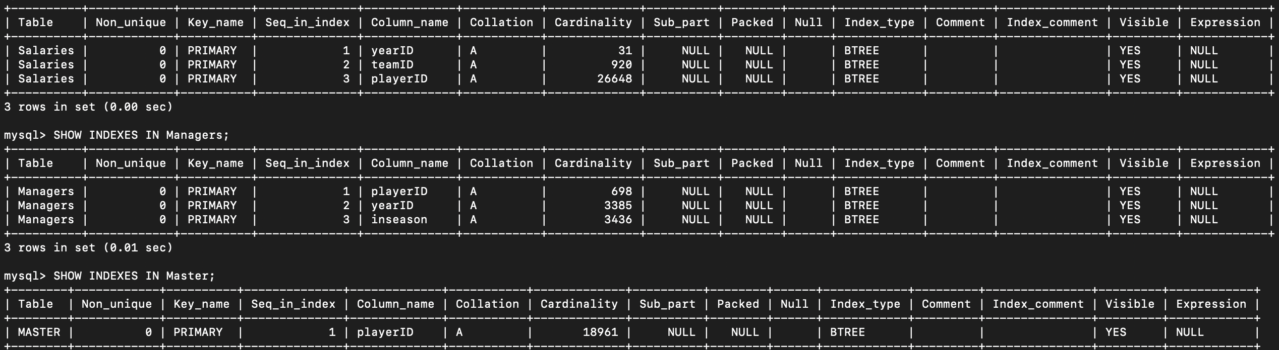

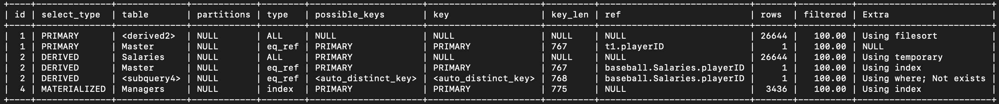

With pk and fk:

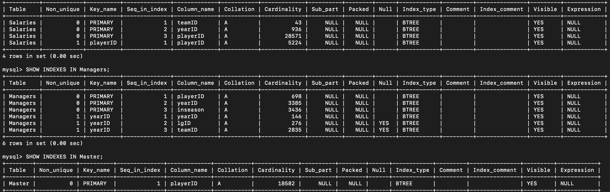



With index:

All the needed index has been in with pk and fk.

Managers Only:

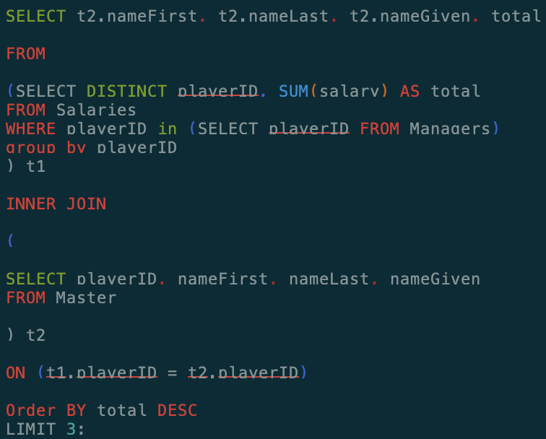

Without any index:



With pk:

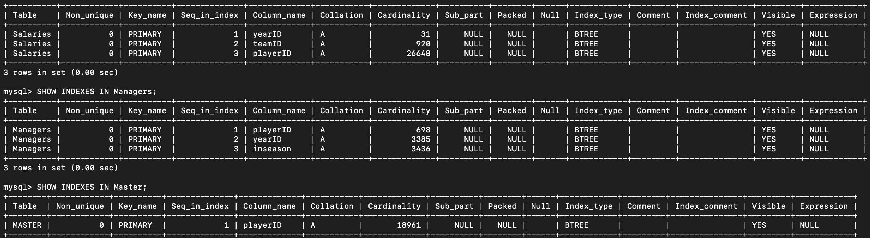



With pk and fk:

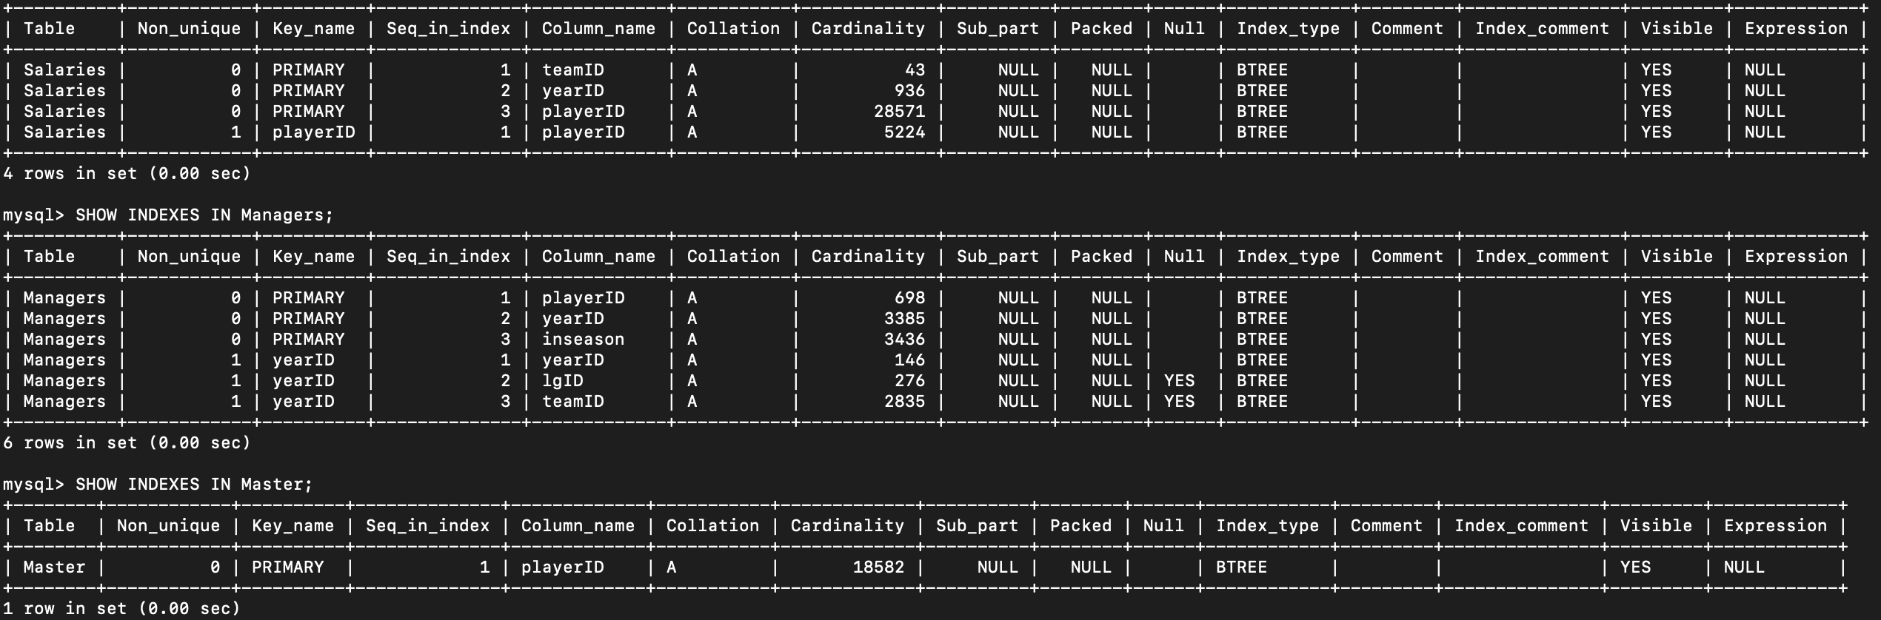



With index:

All the needed index has been in with pk and fk.

Other:

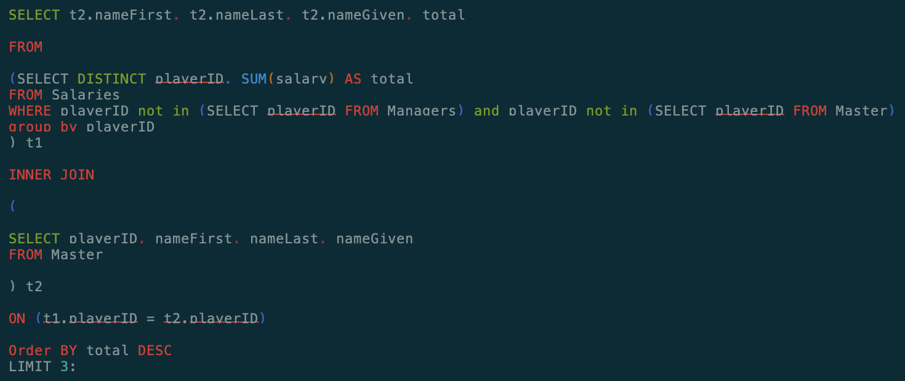

Without any index:

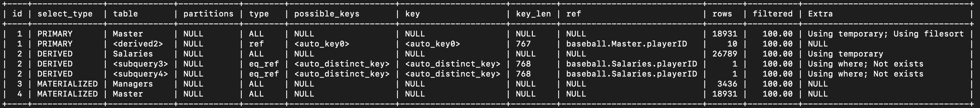

With pk:

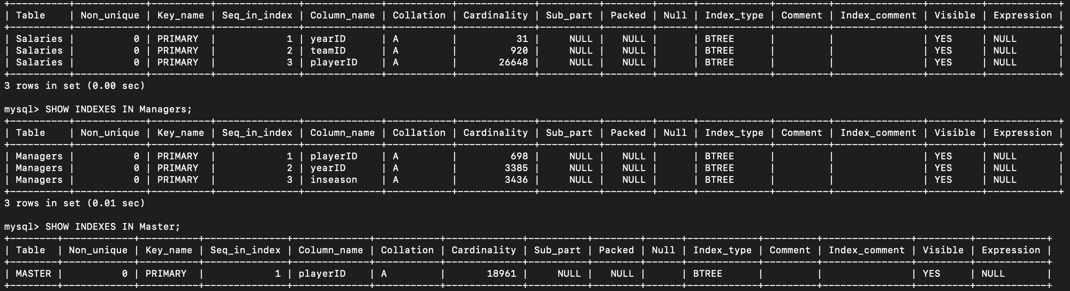

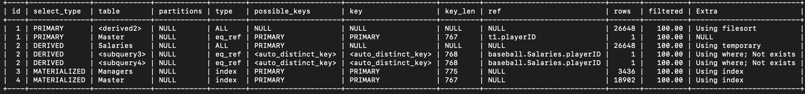

With pk and fk:

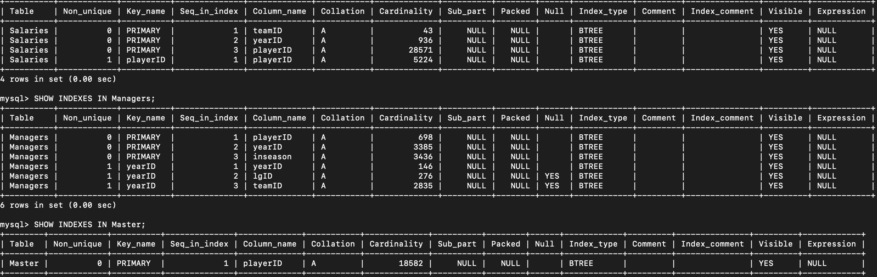

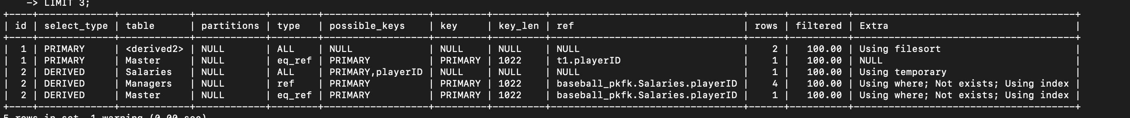

With index:

All the needed index has been in with pk and fk.

(d) What is the average number of Home Runs a player has?

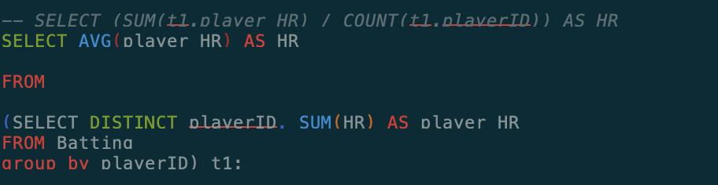

Without any index:



With pk:





With pk and fk:

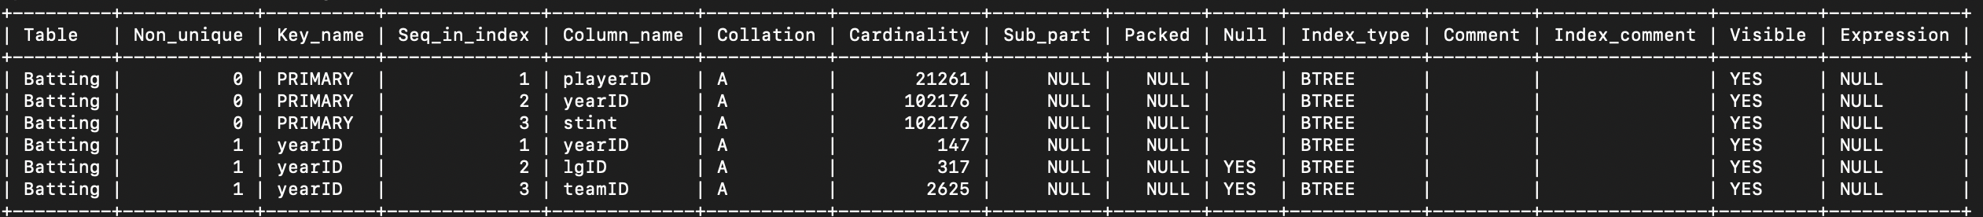



With index:

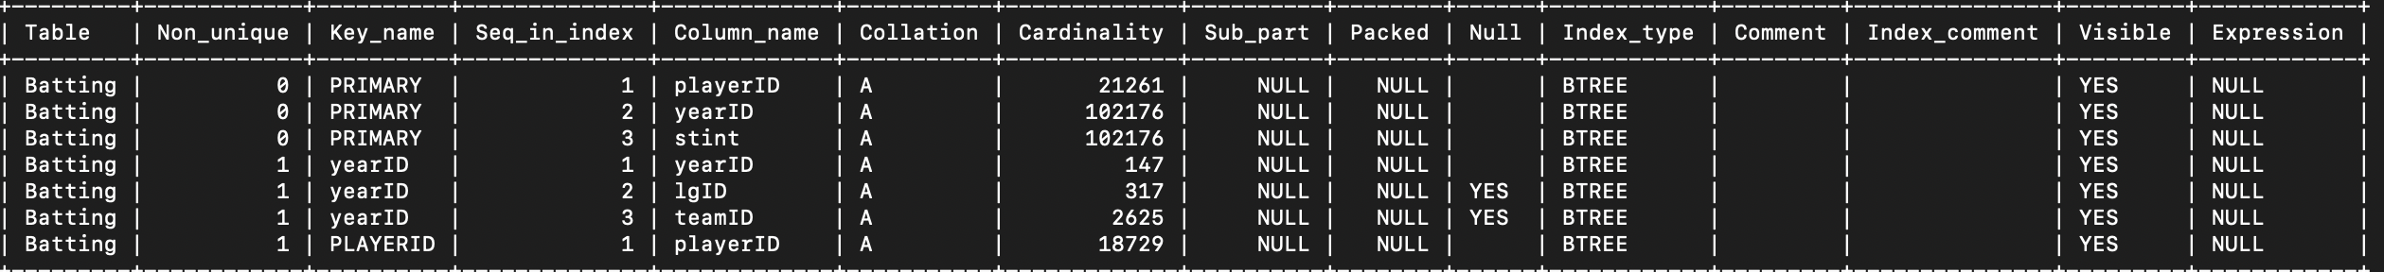



(e) If we only count players who got at least 1 Home Run, what is the average number of HomeRuns a player has?

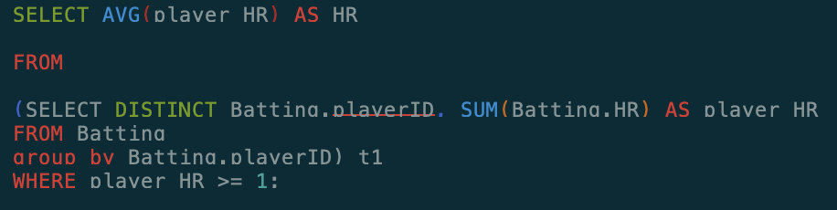

Without any index:



With pk:





With pk and fk: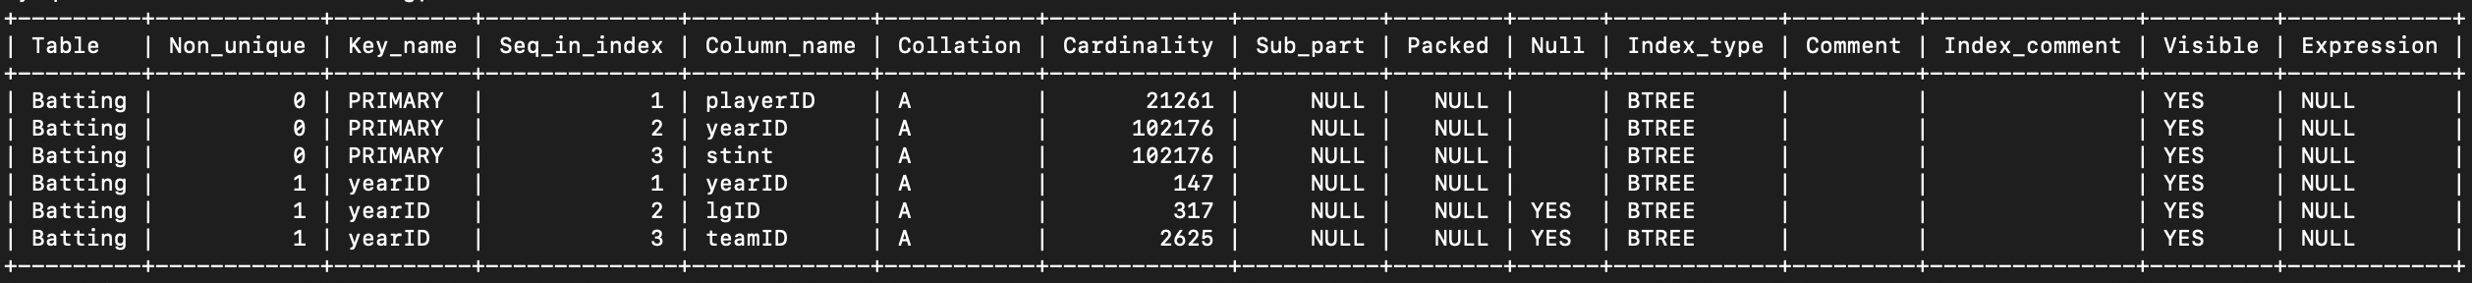



With index:

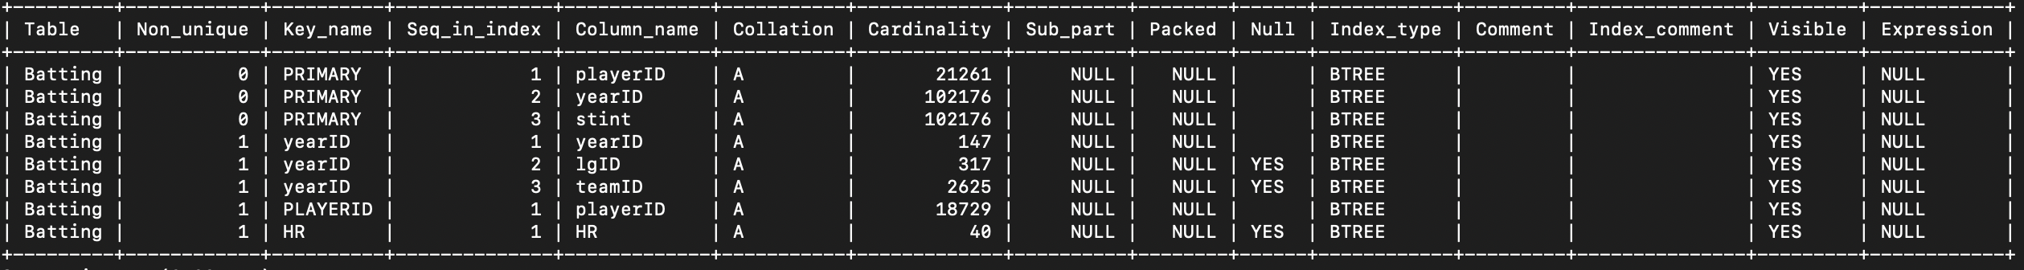



(f) If we define a player as a good batter if they have more than the average number of HomeRuns, and a player is a good Pitcher if they have more than the average number of ShutOut games, then how many players are both good batters and good pitchers?

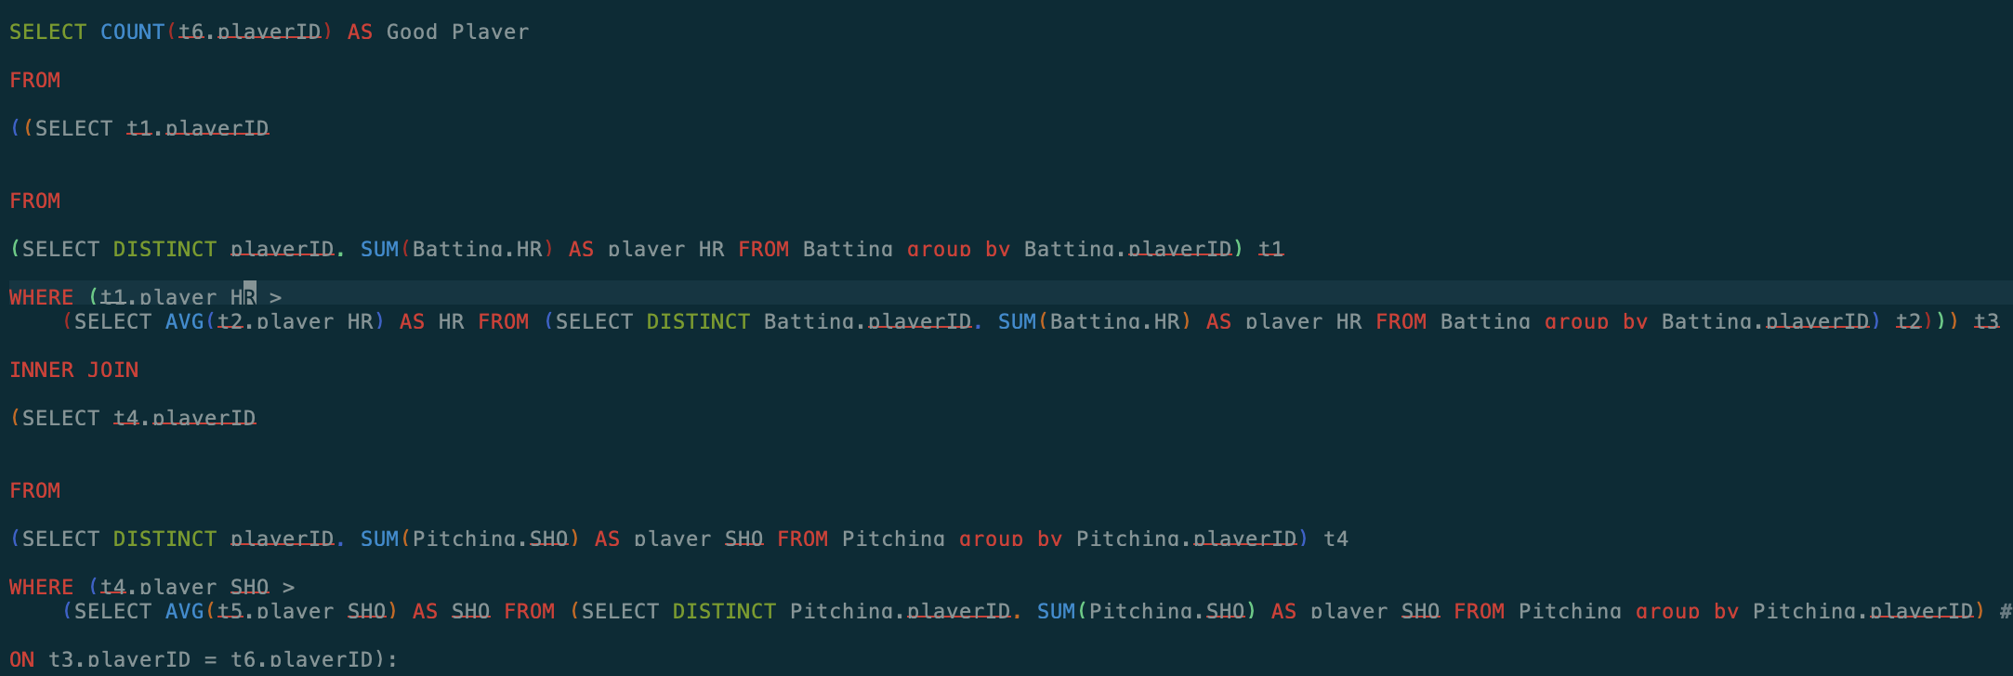

Without any index:

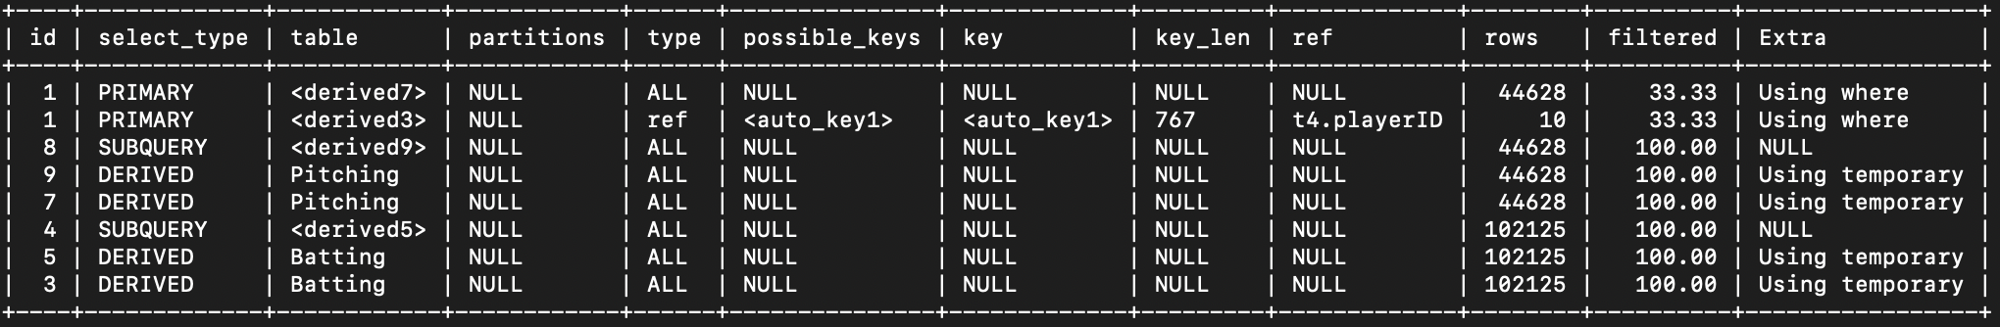

With pk:

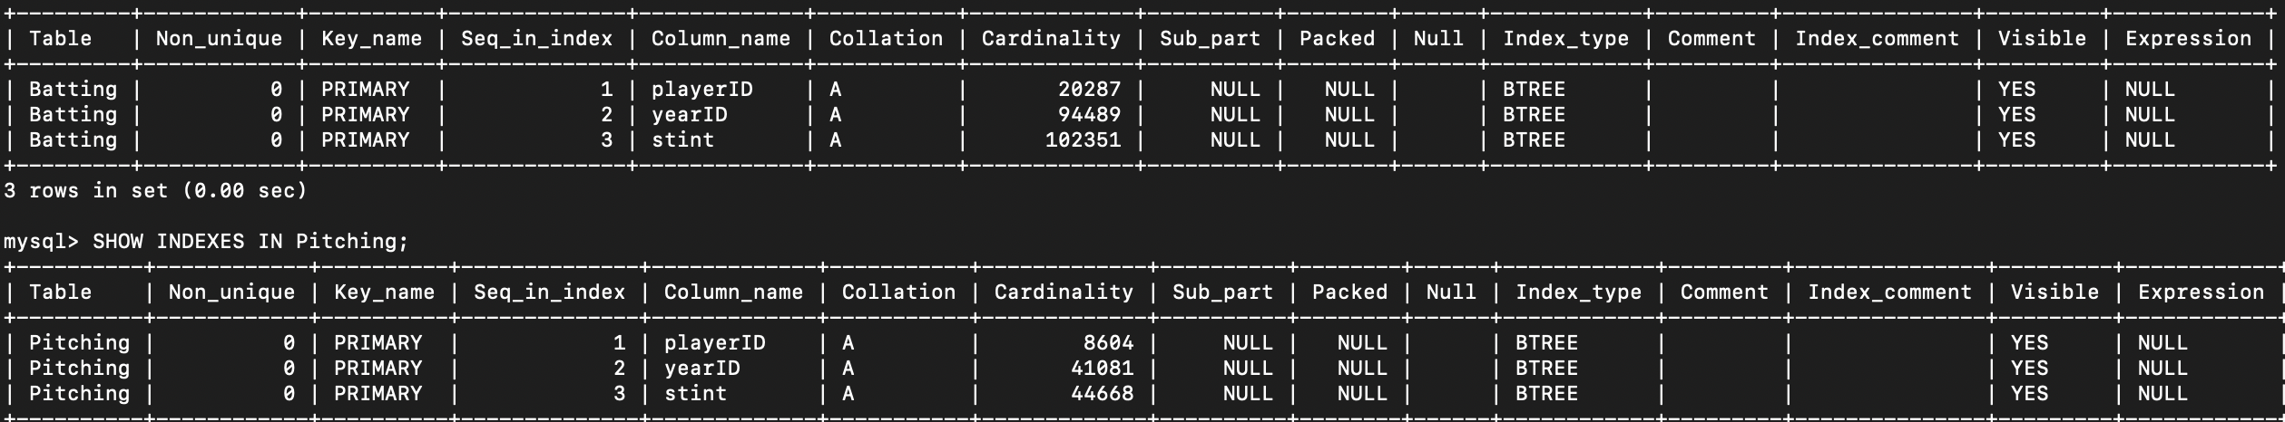

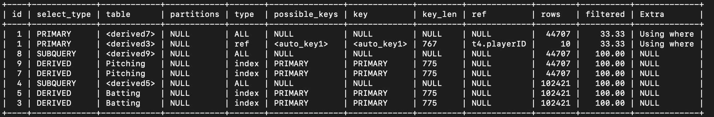

With pk and fk:

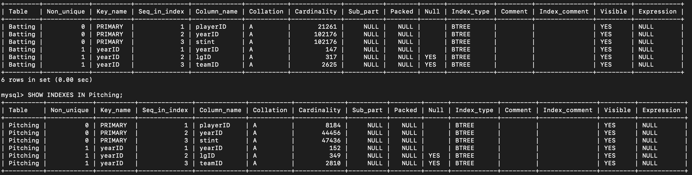

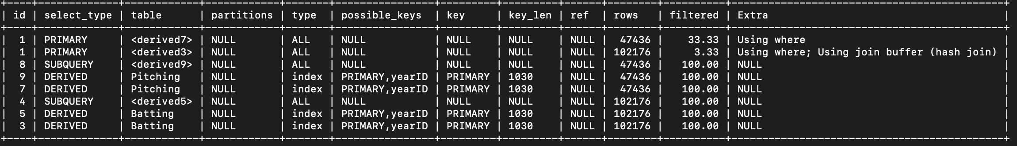

With index:

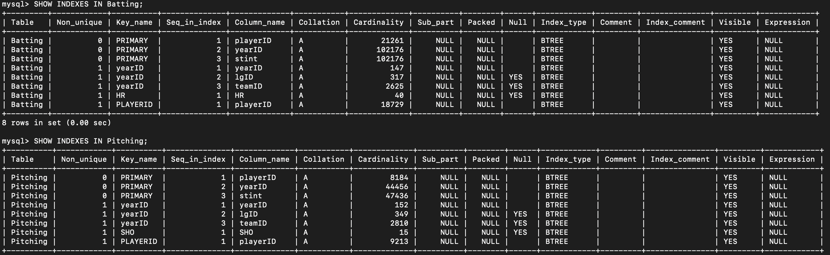

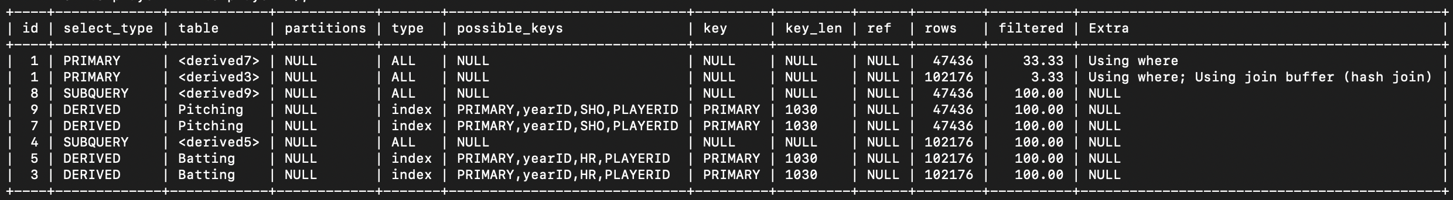

Conclusion:

For the results in question a and the first part of question b, after we add some important index, the rows to scan decrease a lot!

For the results in question b, we can get the importance of primary key, and it can dramatically improve our performance sometimes, and based on the primary key, we add some index, then get a better performance.

For the results in question c, we can see the importance of foreign key, sometimes when we add foreign key, the mysql also add some important index for us which could improve our performance because our inner join operation and group by operation can be improved.

For the results in question d, e, f, we can see the queries and get that all the inner queries need to scan the table because of the aggregate function sum; thus, there is no performance improvement by adding indexes, primary key, foreign key.